**DAILY ONLINE ACTIVITIES SUMMARY**

|  |  |  |  |  |  |  |  |  |
| --- | --- | --- | --- | --- | --- | --- | --- | --- |
| **Date:** | **04/06/2020** | | | | | **Name:** | **PONICA.J** | |
| **Sem & Sec** | **4TH & B** | | | | | **USN:** | **4AL18CS055** | |
| **Online Test Summary** | | | | | | | | |
| **Subject** | | **MES** | | | | | | |
| **Max. Marks** | | **20** | | **Score** | | | **17** | |
| **Certification Course Summary** | | | | | | | | |
| **Course** | **MASTER RECURSION BACKTRACING** | | | | | | | |
| **Certificate Provider** | | | **GUVI** | | **Duration** | | | **4 HOURS** |
| **Coding Challenges** | | | | | | | | |
| **Problem Statement:** Given an array C of size N-1 and given that there are numbers from 1 to N with one element missing, the missing number is to be found. | | | | | | | | |
| **Status:EXECUTED** | | | | | | | | |
| **Uploaded the report in Github** | | | | | **YES** | | | |
| **If yes Repository name** | | | | | **https://github.com/ponica-jaya/LOCKDOWN-CODING.git** | | | |
| **Uploaded the report in slack** | | | | | **YES** | | | |

Online Test Details: (Attach the snapshot and briefly write the report for the same)

TODAY (04/06/2020) I HAD TEST ON THE SUBJECT MES AND PORTIONS WAS MODULE 3 AND V HAD IT AT 2.00PM TO 2.30PM.I HAVE TOOK UP MY TEST AND ALSO I HAVE ATTACHED MY SCORE SNAPSHOT BELOW.

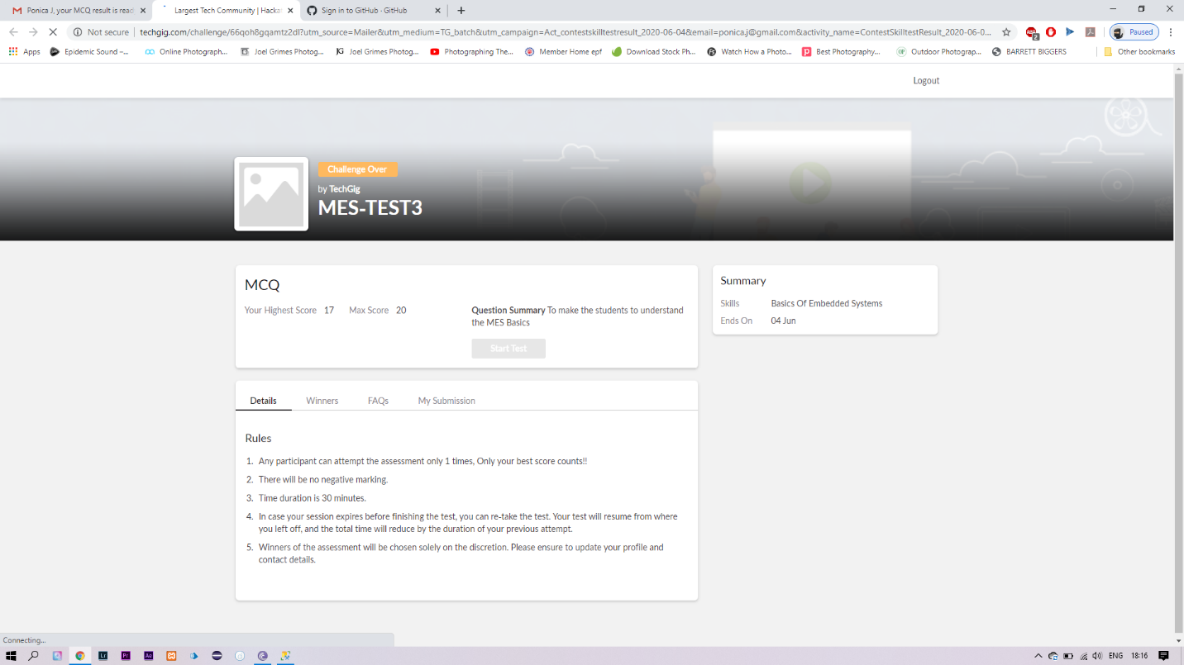

Certification Course Details: (Attach the snapshot and briefly write the report for the same)

TODAY I TOOK A TOPIC OF MASTER RECURSION BACKTRACKING WHICH IS A FREE COURSE AND IT IS FOR 4 HOURS.I HAVE ATTACHED THE SNAPSHOTS OF THE COURSE WHICH ATTENDED IT TODAY.

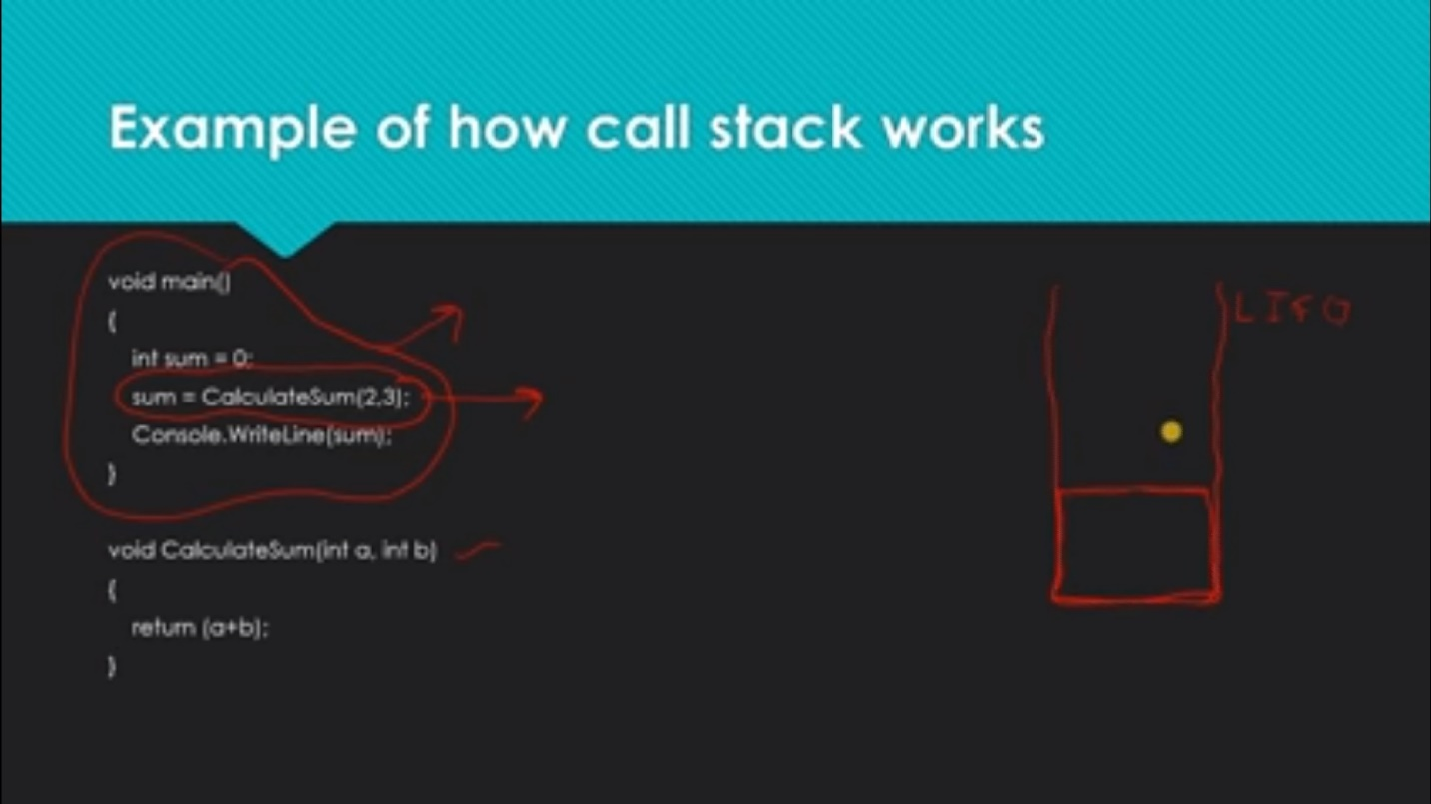

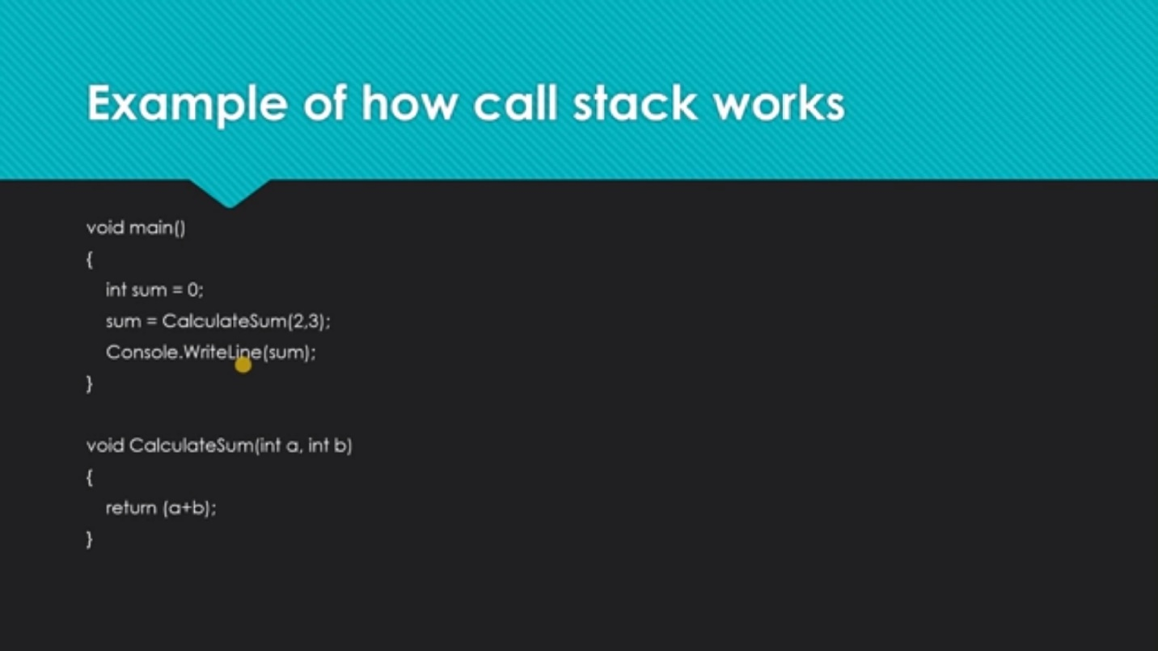

Coding Challenges Details: (Attach the snapshot and briefly write the report for the same)

TODAY I GOT PROBLEM ON C++.

Given an array C of size N-1 and given that there are numbers from 1 to N with one element missing, the missing number is to be found.

**Input:**  
The first line of input contains an integer T denoting the number of test cases. For each test case first line contains N(size of array). The subsequent line contains N-1 array elements.

**Output:**  
Print the missing number in array.

**Constraints:**  
1 ≤ T ≤ 200  
1 ≤ N ≤ 107  
1 ≤ C[i] ≤ 107

Example:  
Input:  
1  
5  
1 2 3 5

Output:  
4

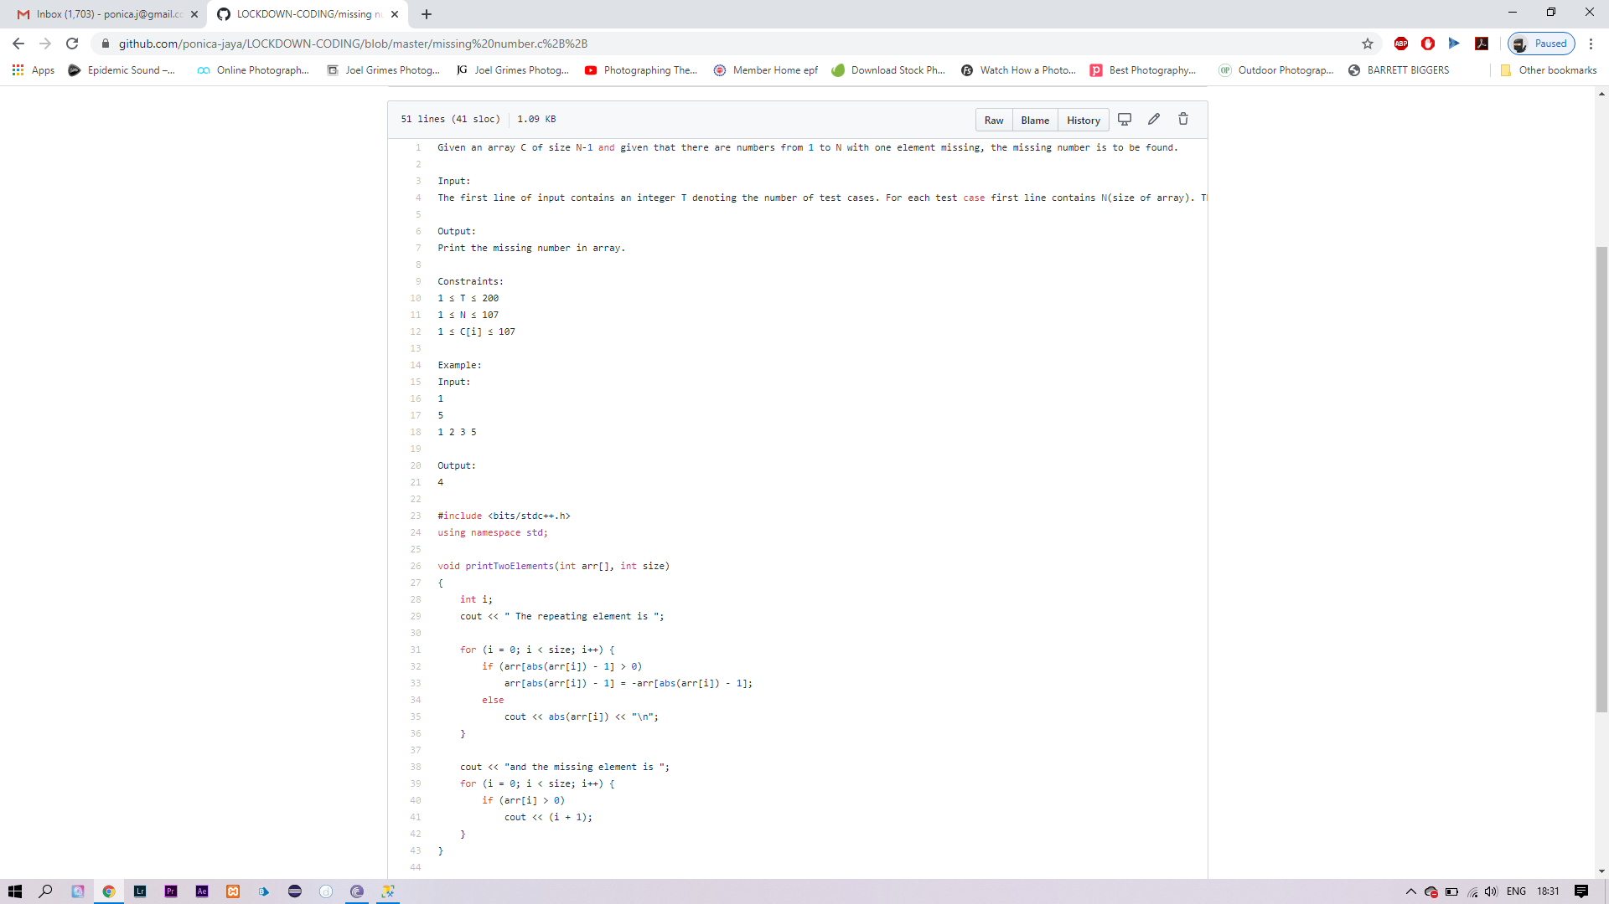

SOLUTION I HAVE SOLVED AND UPLOADED IN GITHUB .